**Project Design Phase-II**

**Data Flow Diagram & User Stories**

|  |  |
| --- | --- |
| Date | 03 October 2022 |
| Team ID | PNT2022TMID52022 |
| Project Name | Project – IoT Based Safety Gadgets for Child Safety Monitoring & Notification |
| Maximum Marks | 4 Marks |

**Data Flow Diagrams:**

A Data Flow Diagram (DFD) is a traditional visual representation of the information flows within a system. A neat and clear DFD can depict the right amount of the system requirement graphically. It shows how data enters and leaves the system, what changes the information, and where data is stored.

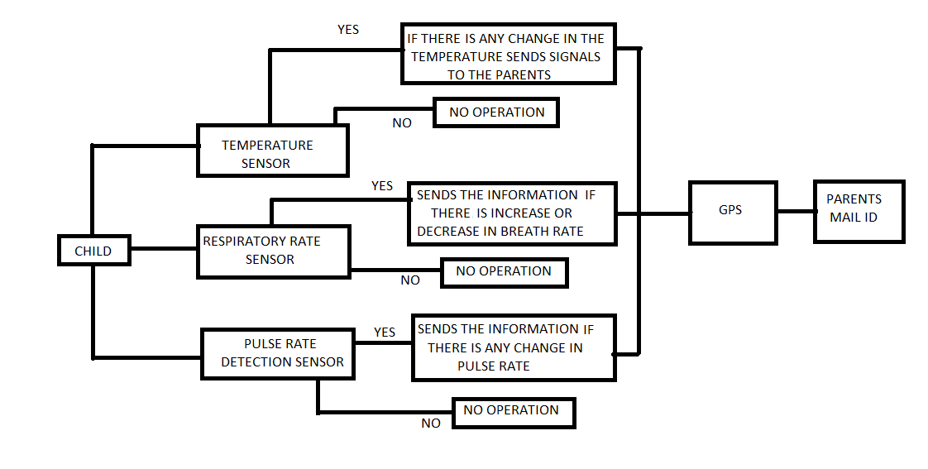

**User Stories**

Use the below template to list all the user stories for the product.

| **User Type** | **Functional Requirement (Epic)** | **User Story Number** | **User Story / Task** | **Acceptance criteria** | **Priority** | **Release** |
| --- | --- | --- | --- | --- | --- | --- |
| Customer (Mobile user) | Registration | USN-1 | As a user, I can register for the application by entering my email, password, and confirming my password. | I can access my account / dashboard | High | Sprint-1 |
|  |  | USN-2 | As a user, I will receive confirmation email once I have registered for the application | I can receive confirmation email & click confirm | High | Sprint-1 |
|  |  | USN-3 | As a user, I can register for the application through Gmail | I can receive verification code and invitation | Medium | Sprint-1 |
| Administrator | Login | USN-4 | As a user, I can log into the application by entering email & password | I can login to my account | High | Sprint-1 |
| Customer  Service | User Data | USN-5 | Ask for normal range of temperature, pulse rate and respiratory rate | I am adding the normal temperature, pulse rate and respiratory rate | High | Sprint-1 |
| Customer | Temperature  Sensing | USN-6 | Sensing the temperature of the child | I can able to receive the data about the temperature of the child | High | Sprint-2 |
| Customer | Respiratory Rate  Sensing | USN-7 | Sensing the respiratory rate sensing of the child | I can able to receive the data about the breathing rate of the child | High | Sprint-2 |
| Customer | Pulse Rate  Sensing | USN-8 | Sensing the pulse rate of the child | I can able to receive the data about the pulse rate of the child | High | Sprint-2 |
| Customer | Location fix | USN-9 | Parents can be able to receive the location of the child | I can able to know the location of where the child is present | High | Sprint-3 |